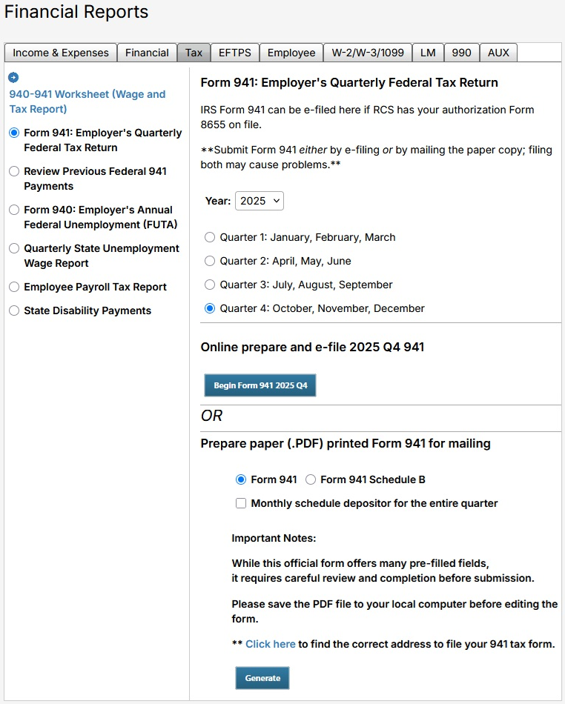

New E-Filing option for IRS Form 941

As promised, RCS is offering employers a new, electronic option for submitting the quarterly IRS Form 941 right from within our program.
Currently, the form can be printed, completed, and (snail) mailed to the IRS.
Going forward, you will have the option to complete and submit the form electronically right from our Tax tab. In the first stage, quarterly payers (only) will also be able to make their accompanying payment from our program with their banking information.

To take advantage of the new feature, the local must submit IRS Form 8655 which will allow RCS to be your “Reporting Agent”. You will not see the new tool until this is complete. Notes:
- RCS offers a partially pre-filled Form 8655

- Be very sure that the tax payer name on line 1a matches the name on file with the IRS.
If in doubt, go to: https://apps.irs.gov/app/eos/ and enter your EIN to confirm.
This can also be confirmed by looking at a recent Form 990 that was e-filed with the IRS.

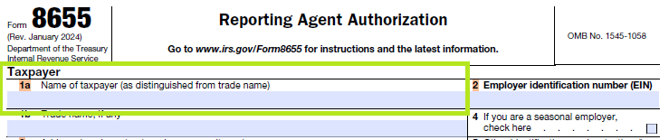

- An employer can have just one “Reporting Agent” at a time. Bear this in mind if you previously designated QuickBooks or another provider. If you submit this form, you would only be able to Efile via RCS going forward.
- The form is submitted just once, no need to renew annually.
- To submit this form, please email a completed and signed copy to 941@rcsunionsoftware.com and you will receive a confirmation that we received that and will begin the process of faxing it over to the IRS (this process can take up to a couple of weeks).

When IRS form 8655 is on file with RCS and the new program is activated, there will be an additional option on screen for E-Filing. (Reminder, do not submit the form BOTH ways for the same quarter.)
Steps to Complete and File IRS Form 941 Employer’s Quarterly Federal Tax Return
- Go to Financial Reports > Tax tab > Form 941
- Select the Year and Quarter to be reported
- Choose your method
  - To E-File, select button “Begin Form 941…”
  - Alternatively, to print and mail your form, make your selections and use the button “Generate”
- For both options, you will see the majority of the information is pre-filled. You should complete box 13 to indicate any previous payments for the period. Box 14 and 15 will depend on your box 13 as always.
(If you are due a refund, we recommend you request a refund.)
For those printing and mailing the form- complete the form (and voucher if sending a payment). There is a link on that menu to locate the correct mailing address to send it. We highly recommend keeping copies for yourself!
- For those E-Filing- complete the form.

Again, on Form 941, be very sure that the “Name” just below the employer’s EIN at the top of the page matches the business name on file with the IRS.
If in doubt, go to: https://apps.irs.gov/app/eos/ and enter your EIN to confirm.
Options at the bottom of the page include:
- Save & Preview as PDF – save changes & save or print a copy for your records
- Save & Run Validations – save and check for any errors
- Save draft – save
- Submit to IRS now – submit the completed form to the IRS.
Note – Quarterly payers (and ONLY quarterly payers) can take advantage of the check box option to pay the IRS here with the local’s routing information. This is an EFW payment to the IRS, which is a different process than EFTPS used by the Department of Revenue for those who pay more frequently. Fill this in prior to submitting the form to include your payment. (Direct payment to EFTPS from the RCS software is currently in development and will be available for Q1 2026).
After you submit the form, we recommend you check back to confirm the submitted file was accepted or rejected by the IRS. Feedback should be available in 30 minutes or less.
Please reach out to your RCS support team for assistance as needed.
Support@rcsunionsoftware.com or 866-727-8291 extension 3.

