2023 LM Prep

The steps below document the process we use here at RCS to verify a local is ready to start the LM report. These cross-checks and tips before starting can prevent wasted time and effort!

- Grab last year’s LM for comparison:
LM2: Note the 2022 ending cash figure in line 22, column B
LM3: Note the 2022 ending cash figure in line 25, column B
If needed, you can retrieve past LM filings on the DOL’s site:

- Go To: https://olmsapps.dol.gov/query/getOrgQry.do
- Retrieve your local either by
- Enter your LM File Number & click <submit>
- or “search by”:
    - Select by your union type. IE UAW = UAW-AUTO WORKERS AFL-CIO next to “Union Name by Abbreviation”
(It’s about 1/10th of the way down the huge list of Union Names! Not at the bottom as expected.)
    - Fill in your local number next to “Designation Number”
    - Select <Submit> at bottom of screen to see matching results.
- Scan your results for your local and the year. Click to open and print it.

- Run the December 2023 A-43. Compare & review.
From the top menu, select Reports, then the Financial Tab. Run the Cash & Fund Summary Report for December of 2023 (all funds).

  - Verify that the “Total Cash Assets-Previous Month” for January 2023 matches the number found above on the 2021 LM (line 22 or 25, column B).
  - Verify that the Balance to Account, Total Cash Assets, and Total Funds match each month on the A-43.

- Run the LM Worksheet
From the top menu, choose Reports then the LM Tab. Run the LM Worksheet for 2023 and review. Watch out for any “Error” warnings or any other unexpected results.
Check out the local’s officers for the year on the worksheet for LM3. LM2 filers can review them by running Schedule 11. Make any needed corrections before proceeding!
Contact our support (866-727-8291) with any concerns.

- Run the Financial Report for the year
From the top menu, choose Reports then the Financial Tab. Run the Financial Report for the year.
  - Verify that the income on the Financial Report and the Total Receipts on the LM Worksheet match.
  - Verify that the expenses on the Financial Report and the Total Disbursements on the LM Worksheet match. There may be a variance if you have any voids from a previous year- this is acceptable.
Rounding can result in a variance of a few dollars- this is acceptable.


If any of the above don’t match, then your data is not yet in balance.
Review and correct this before you continue!

- Confirm that your federal tax payments (941) are split between accounts 383, 384, 402.
You can see these amounts on your LM Worksheet.
LM3 filers – review expense lines 48 (for account 402) and line 53 (for 383 & 384)
LM2 filers – review expense lines 65 (for account 402) and line 67B (for 383 & 384)

To review how your federal tax checks should be recorded in the software – check out our RCS University video titled “EFTPS Payments Towards 941” at: RCS University
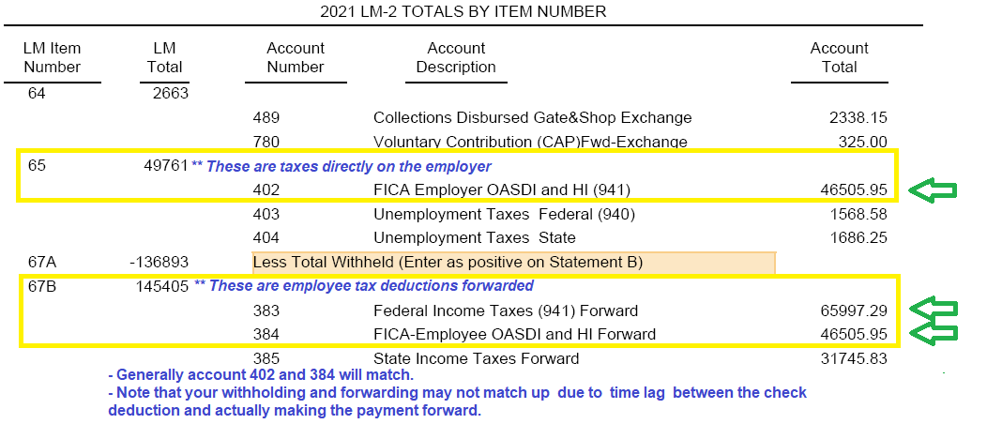
There is also a link to RCS University on the Dashboard. Password: university

- Officer Updates

To view the employees currently identified as officers:
- LM3 filers can run an LM Worksheet
- LM2 filers can run Schedule 11

  - Officer Status (As of 12/31/2023) – Update the “Officer” field on the employees’ 2023 & 2024 Personal Info tab.
If the employee held no position during the year, then this field should be blank.
  - New Officer = Newly Elected during the year, still holds position as of 12/31.
  - Continued Officer = Continued from the previous year, still holds the position as of 12/31.
  - Past Officer = Held an officer title during the year, but not as of 12/31.
  - Officer Title & Address – Confirm that all officers have accurate and current titles and addresses.

We can’t stress the importance of this step enough – the employee records must show the correct officer statuses at year end before you start the LM. Changing officer statuses later generally requires reloading ALL of the expense schedules.

If you have trouble with the steps above – check out our RCS University video titled “Year End Prep – Updating Officer Statuses” at: RCS University

There is also a link to RCS University on the Dashboard. Password: university

* LM3 filers can stop here. * LM2 filers please continue…

7. LM2 Check Up – Look out for Warnings!

From the top menu, choose Reports then LM. Select the Schedules option, then All Schedules & Exports. Run the Vendor Report the full year, select Expense & Totals Only

- If a red box like the one pictured below appears, fix the errors as prescribed. Errors will relate to vendors whose transactions total $5,000 or more. These vendors will be itemized and imported into your LM2. Errors will relate to the vendor name, address, business type or purpose.

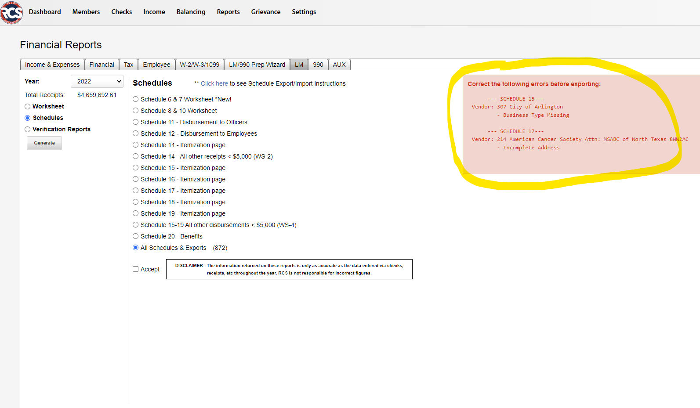

- If the red warning box does not appear, then there are no itemized vendor-related informational errors.

