2022 LM Prep for Wizards

The steps below document the process we use here at RCS to verify a local is ready to start the LM report. These cross-checks and tips before starting can prevent wasted time and effort!

- Grab last year’s LM for comparison:
LM2: Note the 2021 ending cash figure in line 22, column B
LM3: Note the 2021 ending cash figure in line 25, column B
If needed, you can retrieve past LM filings on the DOL’s site:

- Go To: https://olmsapps.dol.gov/query/getOrgQry.do
- Retrieve your local either by
- Enter your LM File Number & click <submit>
- or “search by”:
    - Select by your union type. IE UAW = UAW-AUTO WORKERS AFL-CIO next to “Union Name by Abbreviation”
(It’s about 1/10th of the way down the huge list of Union Names! Not at the bottom as expected.)
    - Fill in your local number next to “Designation Number”
    - Select <Submit> at bottom of screen to see matching results.
- Scan your results for your local and the year. Click to open and print it.

- Run the 2022 A-43. Compare & review.
From the top menu, select Reports, then the Financial Tab. Run the Cash & Fund Summary Report for December of 2022 (all funds).

  - Verify that the “Total Cash Assets-Previous Month” for January 2022 matches the number found above on the 2021 LM (line 22 or 25, column B).
  - Verify that the Balance to Account, Total Cash Assets, and Total Funds match each month on the A-43.

- Run the LM Worksheet
From the top menu, choose Reports then the LM Tab. Run the LM Worksheet for 2022 and review. Watch out for any “Error” warnings or any other unexpected results.
Contact our support (866-727-8291) with any concerns.

- Run the Financial Report for the year
From the top menu, choose Reports then the Financial Tab. Run the Financial Report for the year.
  - Verify that the income on the Financial Report and the Total Receipts on the LM Worksheet match.
  - Verify that the expenses on the Financial Report and the Total Disbursements on the LM Worksheet match. There may be a variance if you have any voids from a previous year- this is acceptable.
Rounding can result in a variance of a few dollars- this is acceptable.


If any of the above don’t match, then your data is not yet in balance.
Review and correct this before you continue!

- Confirm that your 2022 federal tax payments (941) are split between accounts 383, 384, 402.
You can see these amounts on your LM Worksheet.
LM3 filers – review expense lines 48 (for account 402) and line 53 (for 383 & 384)
LM2 filers – review expense lines 65 (for account 402) and line 67B (for 383 & 384)

To review how your federal tax checks should be recorded in the software – check out our RCS University video titled “EFTPS Payments Towards 941” at: RCS University
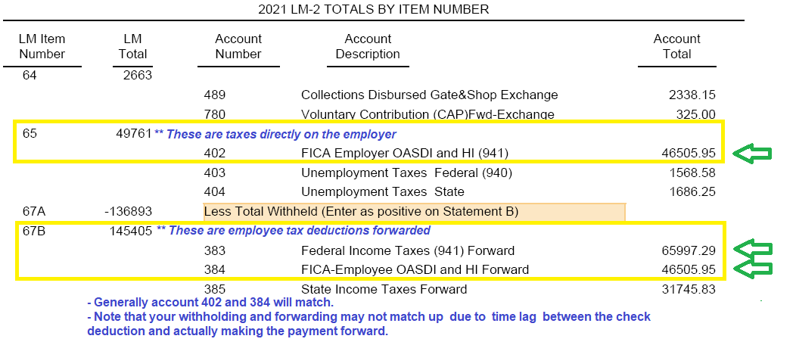
There is also a link to RCS University on the Dashboard. Password: university

- Ensure there are no Vendor-related errors for your LM. Click on the LM tab select Schedules, then All Schedules. If there is an error, a red box will appear, alerting you to what needs correcting. If no red box appears, you are good to go!
